##### 

**American International University - Bangladesh**

**Project Name: Car Ride Hailing Management System**

**Group Members**

|  |  |
| --- | --- |
| **1.Rubina Islam Reya** | **19-39811-1** |
| **2.A. M. Nowfal Nayeef** | **20-42048-1** |
| **3.Md. Washim Akram** | **20-43232-1** |
| **4.Anika Saba Ibte Sum** | **20-43242-1** |
| **5.Sadia Afrin Promi** | **20-43246-1** |

**Course Name: Introduction to Database**

**Section: L**

**Contents**

**Introduction** 2

**Scenario Description** 3

**ER Diagram** 4

**Normalization** 5

**Schema Diagram** 11

**Table Creation** 12

**Data Insertion** 20

**Query Writing** 26

**Relational Algebra** 29

**Conclusion** 30

# **Introduction**

The project entitled as “CAR RIDE HAILING MANAGEMENT SYSTEM” is mainly developed for the overall management of the ‘Car Ride Hailing’. The project is helpful to manage all the information of Owners, Cars, Drivers and Customers. In our Database System We can add customer information as well as drivers and cars also. The database is also helpful for store the information of the different types of Cars for reservation. Customer can also rent a car. This application is created for easy and quick processing to find a car, driver details and customer details. Anyone can easily use our system. We can find which driver or which car was involved with reservation or renting.

# Scenario Description

In a car ride hailing management system a customer may rent many cars. One car may be rented by exactly one customer. A customer is identified by a Customer cell number. The system also stores customer name, address. A customer address is composed of house number, street number and city. A car is identified by car id. Car brand and car type are also stored. There may be multiple brand and type of a car. While renting, the time of the renting of the car is stored. A customer may also reserve a car. A car can be reserved by many customers. To find the priority of the reservation the reserve id, reserve date, reserve time are also stored. A car is owned by at least one owner. An owner may own many cars but the system stores information of those owners of who has owned at least one car stored in the system. To identify the owner the system stores owner id. It also stores owner name, contact and address. An owner address is composed of house number, street number and city. A driver may drive a car. A driver is identified by driver id. The system also stores driver name, contact, license number and address. A driver address is composed of house number, street number and city.

# ER Diagram

# Normalization

**Rent:**

UNF

Rent (Car_ID, Car_Brand, Car_Type, Customer_CellNo., Customer_Name, Customer_HouseNo, Customer_StreetNo, Customer_City, Rent_Time)

1NF

Car_Brand, Car_Type are multivalued attributes.

1. Car_ID, Car_Brand, Car_Type, Customer_CellNo., Customer_Name, Customer_HouseNo, Customer_StreetNo, Customer_City, Rent_Time

2NF

1. Car_ID, Car_Brand, Car_Type

2. Customer_CellNo., Customer_Name, Customer_HouseNo, Customer_StreetNo, Customer_City

3. Rent_Time

3NF

1. Car_ID, Car_Brand, Car_Type,

2. Customer_CellNo., Customer_Name

3. Customer_HouseNo, Customer_StreetNo, Customer_City

4. Rent_Time

Table Creation

1. Car_ID, Car_Brand1, Car_Brand2, Car_Brand3, Car_Type1, Car_Type2, Car_Type3, Customer_CellNo.

2. Customer_CellNo., Customer_Name, CustomerAdd_ID,

3. CustomerAdd_ID, Customer_HouseNo, Customer_StreetNo, Customer_City

4. Car_ID, Customer_CellNo., Rent_Time

**Own:**

UNF

Own (Car_ID, Car_Brand, Car_Type, Owner_ID, Owner_name, Owner_Contact, Owner_HouseNo, Owner_StreetNo, Owner_City)

1NF

Car_Brand, Car_Type, Owner_contact are multivalued attributes.

1. Car_ID, Car_Brand, Car_Type, Owner_ID, Owner_name, Owner_Contact, Owner_HouseNo, Owner_StreetNo, Owner_City

2NF

1. Car_ID, Car_Brand, Car_Type

2. Owner_ID, Owner_name, Owner_Contact, Owner_HouseNo, Owner_StreetNo, Owner_City

3NF

1. Car_ID, Car_Brand, Car_Type

2. Owner_ID, Owner_name, Owner_Contact

3. Owner_HouseNo, Owner_StreetNo, Owner_City

Table Creation

1. Car_ID, Car_Brand1, Car_Brand2, Car_Brand3, Car_Type1, Car_Type2, Car_Type3, Owner_ID

2. Owner_ID, Owner_name, Owner_Contact, OwnerAdd_ID

3. OwnerAdd_ID, Owner_HouseNo, Owner_StreetNo, Owner_City

**Reserve:**

UNF

Reserve (Car_ID, Car_Brand, Car_Type, Customer_CellNo., Customer_Name, Customer_HouseNo, Customer_StreetNo, Customer_City, Reserve_date, Reserve_ID, Reserve_Time)

1NF

Car_Brand, Car_Type are multivalued attributes.

1. Car_ID, Car_Brand, Car_Type, Customer_CellNo., Customer_Name, Customer_HouseNo, Customer_StreetNo, Customer_City, Rent_Time

2NF

1. Car_ID, Car_Brand, Car_Type

2. Customer_CellNo., Customer_Name, Customer_HouseNo, Customer_StreetNo, Customer_City

3. Reserve_date, Reserve_ID, Reserve_Time

3NF

1. Car_ID, Car_Brand, Car_Type,

2. Customer_CellNo., Customer_Name, Customer_HouseNo, Customer_StreetNo, Customer_City

3. Reserve_date, Reserve_ID, Reserve_Time

Table Creation

1. Car_ID, Car_Brand1, Car_Brand2, Car_Brand3, Car_Type1, Car_Type2, Car_Type3, Customer_CellNo.

2. Customer_CellNo., Customer_Name, CustomerAdd_ID

3. CustomerAdd_ID, Customer_HouseNo, Customer_StreetNo, Customer_City

4. Car_ID, Customer_CellNo., Reserve_date, Reserve_ID, Reserve_Time

**Drive:**

UNF

Drive (Car_ID, Car_Brand, Car_Type, Driver_ID, Driver_LicenseNo, Driver_Name, Driver_Contact, Driver_HouseNo, Driver_StreetNo, Driver_City)

1NF

Car_Brand, Car_Type are multi valued attribute.

Car_ID, Car_Brand, Car_Type, Driver_ID, Driver_LicenseNo, Driver_Name, Driver_Contact, Driver_HouseNo, Driver_StreetNo, Driver_City

2NF

1. Car_ID, Car_Brand, Car_Type

2. Driver_ID, Driver_LicenseNo, Driver_Name, Driver_Contact, Driver_HouseNo, Driver_StreetNo, Driver_City

3NF

1. Car_ID, Car_Brand, Car_Type,

2. Driver_ID, Driver_LicenseNo, Driver_Name, Driver_Contact

3. Driver_HouseNo, Driver_StreetNo, Driver_City

Table Creation

1. Car_ID, Car_Brand1, Car_Brand2, Car_Brand3, Car_Type1, Car_Type2, Car_Type3, Driver_ID.

2. Driver_ID, Driver_LicenseNo, Driver_Name, Driver_Contact, DriverAdd_ID

3. DriverAdd_ID, Driver_HouseNo, Driver_StreetNo, Driver_City

**Temporary Tables**

1. Car_ID, Car_Brand1, Car_Brand2, Car_Brand3, Car_Type1, Car_Type2, Car_Type3, **Customer_CellNo.**

2. ~~Customer_CellNo., Customer_Name,~~ **~~CustomerAdd_ID~~**

3. CustomerAdd_ID, Customer_HouseNo, Customer_StreetNo, Customer_City

4. **Car_ID, Customer_CellNo.,** Rent_Time

5. ~~Car_ID, Car_Brand1, Car_Brand2, Car_Brand3, Car_Type1, Car_Type2, Car_Type3,~~ **~~Owner_ID~~**

6. Owner_ID, Owner_name, Owner_Contact, **OwnerAdd_ID**

7. OwnerAdd_ID, Owner_HouseNo, Owner_StreetNo, Owner_City

8. ~~Car_ID, Car_Brand1, Car_Brand2, Car_Brand3, Car_Type1, Car_Type2, Car_Type3,~~ **~~Customer_CellNo.~~**

9. Customer_CellNo., Customer_Name, **CustomerAdd_ID**

10. ~~CustomerAdd_ID, Customer_HouseNo, Customer_StreetNo, Customer_City~~

11. **Car_ID, Customer_CellNo.,** Reserve_date, Reserve_ID, Reserve_Time

12. ~~Car_ID, Car_Brand1, Car_Brand2, Car_Brand3, Car_Type1, Car_Type2, Car_Type3,~~ **~~Driver_ID.~~**

13. Driver_ID, Driver_LicenseNo, Driver_Name, Driver_Contact, **DriverAdd_ID**

14. DriverAdd_ID, Driver_HouseNo, Driver_StreetNo, Driver_City

**Final Tables**

1. Car_ID, Car_Brand1, Car_Brand2, Car_Brand3, Car_Type1, Car_Type2, Car_Type3, **Customer_CellNo., Owner_ID, Driver_ID.**

2. CustomerAdd_ID, Customer_HouseNo, Customer_StreetNo, Customer_City

3. **Car_ID, Customer_CellNo.,** Rent_Time

4. Owner_ID, Owner_name, Owner_Contact, **OwnerAdd_ID**

5. OwnerAdd_ID, Owner_HouseNo, Owner_StreetNo, Owner_City

6. Customer_CellNo., Customer_Name, **CustomerAdd_ID**

7. **Car_ID, Customer_CellNo.,** Reserve_date, Reserve_ID, Reserve_Time

8. Driver_ID, Driver_LicenseNo, Driver_Name, Driver_Contact, **DriverAdd_ID**

9. DriverAdd_ID, Driver_HouseNo, Driver_StreetNo, Driver_City

# **Schema Diagram**

# **Table Creation**

1. CREATE USER CHOLO IDENTIFIED BY password; 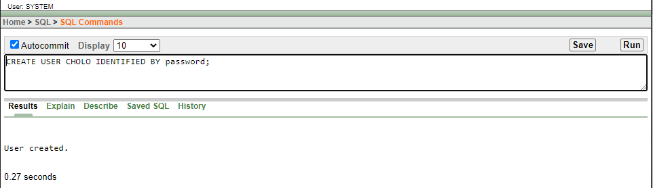
2. GRANT CONNECT, RESOURCE, UNLIMITED TABLESPACE TO CHOLO; 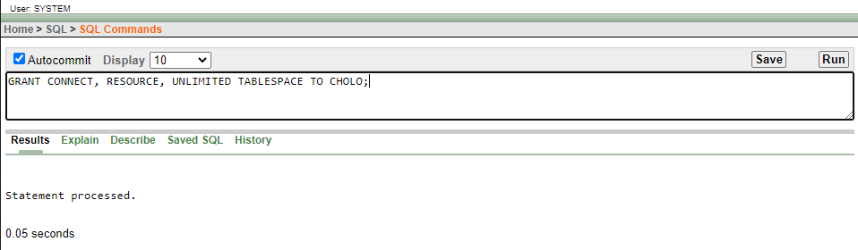
3. CREATE ROLE Owner; 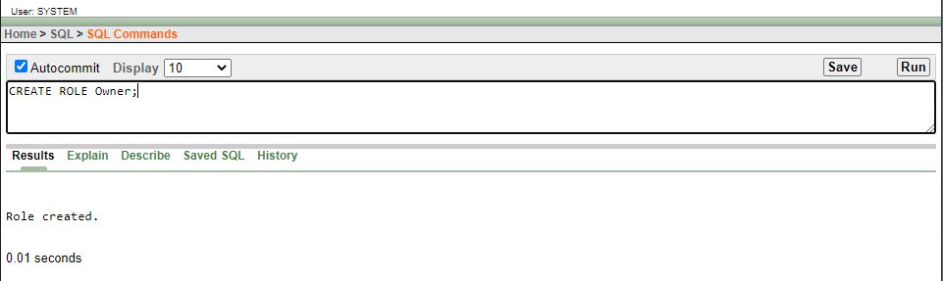

After Login into User ID CHOLO

4. CREATE TABLE Owner_Address(OwnerAdd_ID Number(10) PRIMARY KEY,

Owner_HouseNo Varchar2 (10),

Owner_StreetNo Varchar2(10),

Owner_City Varchar2 (10)

);

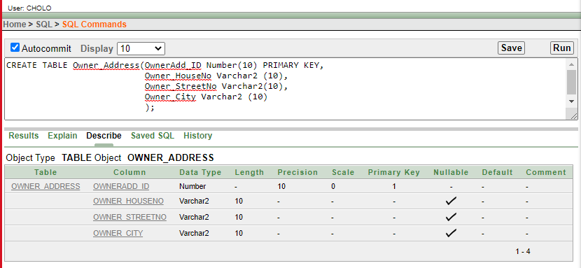

5. CREATE TABLE Owner(Owner_ID Number(10) PRIMARY KEY,

Owner_Name Varchar2 (20),

Owner_Contact Number(20),

OwnerAdd_ID Number (10),

FOREIGN KEY (OwnerAdd_Id) REFERENCES

Owner_Address(OwnerAdd_ID)

); 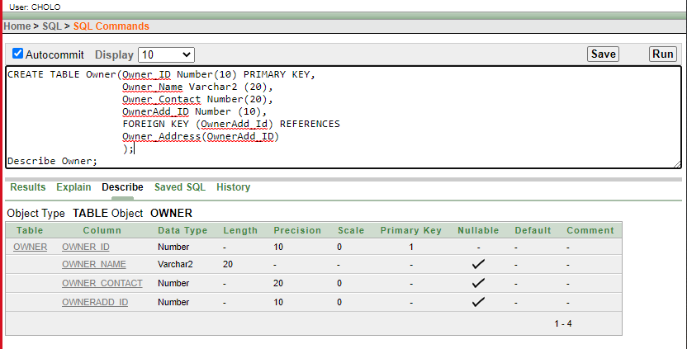

6. CREATE TABLE Driver_Address(DriverAdd_ID Number(10) PRIMARY KEY,

Driver_HouseNo Varchar2 (10),

Driver_StreetNo Varchar2(10),

Driver_City Varchar2 (10)

);

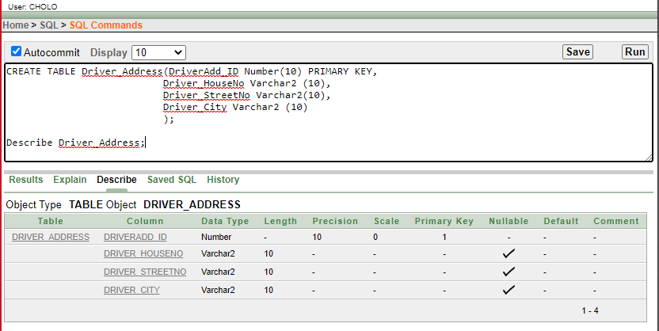

7. CREATE TABLE Driver(Driver_ID Number(10) PRIMARY KEY,

Driver_LicenseNo Varchar2 (20),

Driver_Name Varchar2(20),

Driver_Contact Number (20),

DriverAdd_ID Number (10),

FOREIGN KEY (DriverAdd_ID) REFERENCES Driver_Address(DriverAdd_ID)

); 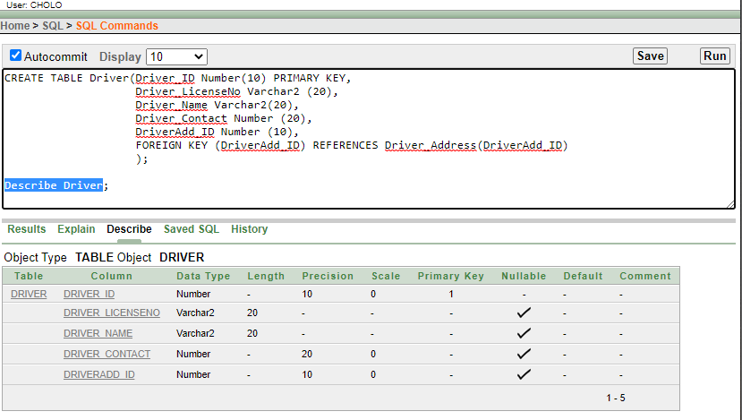

8. CREATE TABLE Customer_Address(CustomerAdd_ID Number(10) PRIMARY KEY,

Customer_HouseNo Varchar2 (20),

Customer_StreetNo Varchar2(20),

Customer_City Varchar2 (20)

); 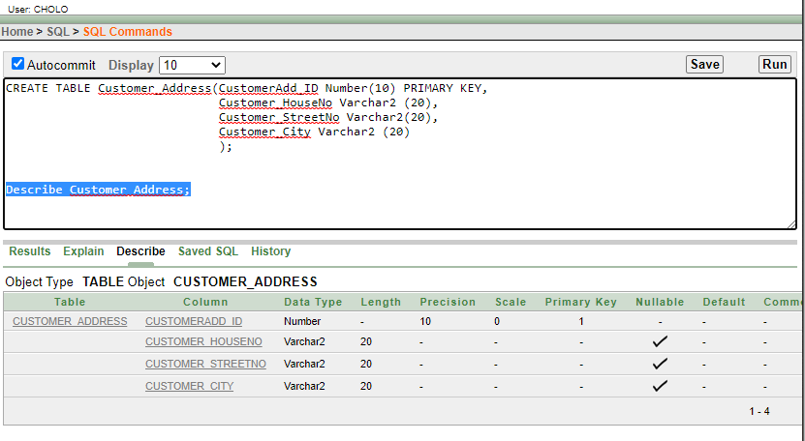

9. CREATE TABLE Customer(Customer_CellNo Number(20) PRIMARY KEY,

Customer_Name Varchar2 (20),

CustomerAdd_ID Number(10),

FOREIGN KEY (CustomerAdd_ID) REFERENCES

Customer_Address(CustomerAdd_ID)

); 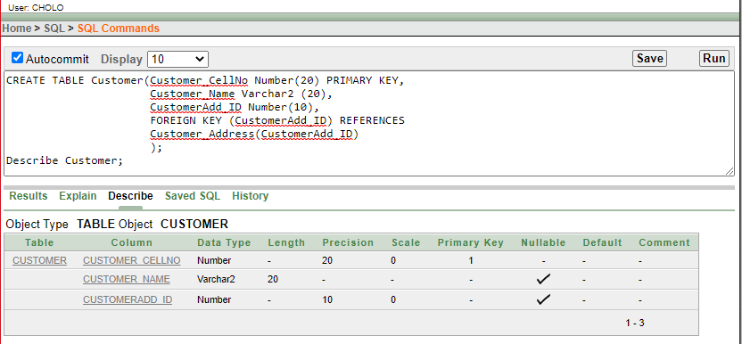

10. CREATE TABLE Car(Car_ID Number(10) PRIMARY KEY,

Car_Brand1 Varchar2 (10),

Car_Brand2 Varchar2 (10),

Car_Brand3 Varchar2 (10),

Car_Type1 Varchar2 (10),

Car_Type2 Varchar2 (10),

Car_Type3 Varchar2 (10),

Customer_CellNo Number (20),

Owner_ID Number(10),

Driver_ID Number(10),

FOREIGN KEY (Customer_CellNo) REFERENCES Customer(Customer_CellNo),

FOREIGN KEY (Owner_ID) REFERENCES Owner(Owner_ID),

FOREIGN KEY (Driver_ID) REFERENCES Driver(Driver_ID)

);

ALTER TABLE Car MODIFY (Car_Brand1 not null);

ALTER TABLE Car MODIFY (Car_Type1 not null);

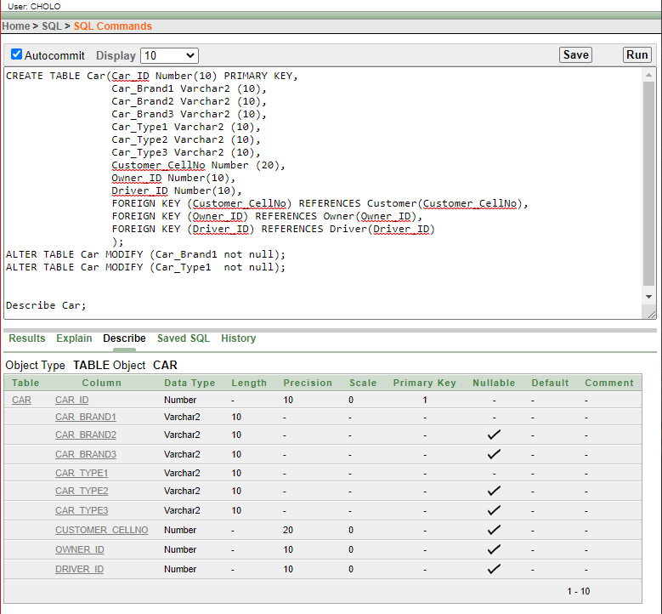

11. CREATE TABLE Rent (Car_ID number(10),

FOREIGN KEY (Car_ID) REFERENCES Car(Car_ID),

Customer_CellNo number(20),

FOREIGN KEY (Customer_CellNo) REFERENCES Customer(Customer_CellNo),

Rent_Time Varchar(10)

);

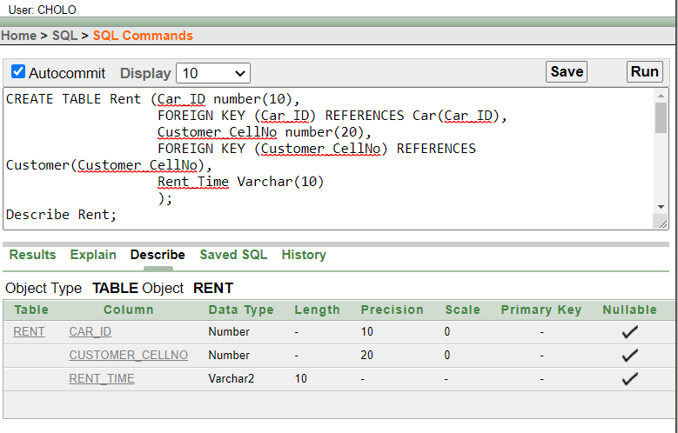

12. CREATE TABLE Reserve (Car_ID Number(10),

FOREIGN KEY (Car_ID) REFERENCES Car(Car_ID),

Customer_CellNo Number(20),

FOREIGN KEY (Customer_CellNo) REFERENCES Customer(Customer_CellNo),

Reserve_Date Date,

Reserve_ID Number(10),

Reserve_Time varchar(10)

);

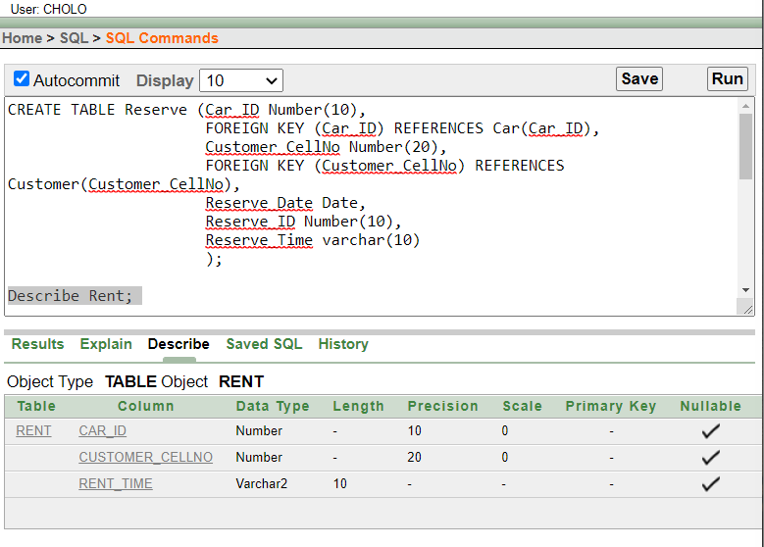

**Create Sequence**

1. CREATE SEQUENCE Owner_Owner_ID

INCREMENT BY 1

START WITH 1

MAXVALUE 500

NOCACHE

NOCYCLE;

2. CREATE SEQUENCE Owner_Address_OwnerAdd_ID

INCREMENT BY 1

START WITH 1

MAXVALUE 500

NOCACHE

NOCYCLE;

3. CREATE SEQUENCE Driver_Driver_ID

INCREMENT BY 1

START WITH 1

MAXVALUE 500

NOCACHE

NOCYCLE;

4. CREATE SEQUENCE Driver_DriverAdd_ID

INCREMENT BY 1

START WITH 1

MAXVALUE 600

NOCACHE

NOCYCLE;

5. CREATE SEQUENCE Car_Car_ID

INCREMENT BY 1

START WITH 1

MAXVALUE 1000

NOCACHE

NOCYCLE;

# **Data Insertion**

1. **Owner_Address**

INSERT INTO Owner_Address(OwnerAdd_ID,Owner_HouseNo,Owner_StreetNo,Owner_City) VALUES (Owner_Address_OwnerAdd_ID.NEXTVAL,'H12','Mirpur 10','Dhaka');

INSERT INTO Owner_Address(OwnerAdd_ID,Owner_HouseNo,Owner_StreetNo,Owner_City) VALUES (Owner_Address_OwnerAdd_ID.NEXTVAL,'H10','Mirpur 14','Dhaka');

INSERT INTO Owner_Address(OwnerAdd_ID,Owner_HouseNo,Owner_StreetNo,Owner_City) VALUES (Owner_Address_OwnerAdd_ID.NEXTVAL,'H105','Uttara 13','Dhaka');

INSERT INTO Owner_Address(OwnerAdd_ID,Owner_HouseNo,Owner_StreetNo,Owner_City) VALUES (Owner_Address_OwnerAdd_ID.NEXTVAL,'H123','Mirpur 12','Dhaka');

INSERT INTO Owner_Address(OwnerAdd_ID,Owner_HouseNo,Owner_StreetNo,Owner_City) VALUES (Owner_Address_OwnerAdd_ID.NEXTVAL,'H193','Badda 7C','Dhaka');

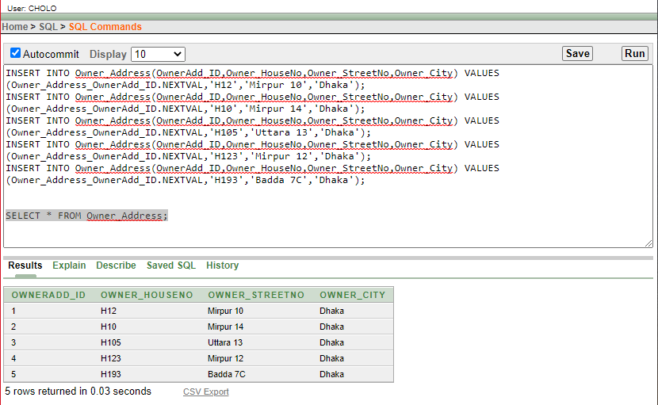

1. **Owner**

INSERT INTO Owner(Owner_ID,Owner_Name,Owner_Contact,OwnerAdd_ID) VALUES (Owner_Owner_ID.NEXTVAL,'Nayeef','8801734901212',1);

INSERT INTO Owner(Owner_ID,Owner_Name,Owner_Contact,OwnerAdd_ID) VALUES (Owner_Owner_ID.NEXTVAL,'Anika','8801760533183',2);

INSERT INTO Owner(Owner_ID,Owner_Name,Owner_Contact,OwnerAdd_ID) VALUES (Owner_Owner_ID.NEXTVAL,'Promi','8801845378914',3);

INSERT INTO Owner(Owner_ID,Owner_Name,Owner_Contact,OwnerAdd_ID) VALUES (Owner_Owner_ID.NEXTVAL,'Rubina','8801356789435',4);

INSERT INTO Owner(Owner_ID,Owner_Name,Owner_Contact,OwnerAdd_ID) VALUES (Owner_Owner_ID.NEXTVAL,'Ovi','8801612367834',5);

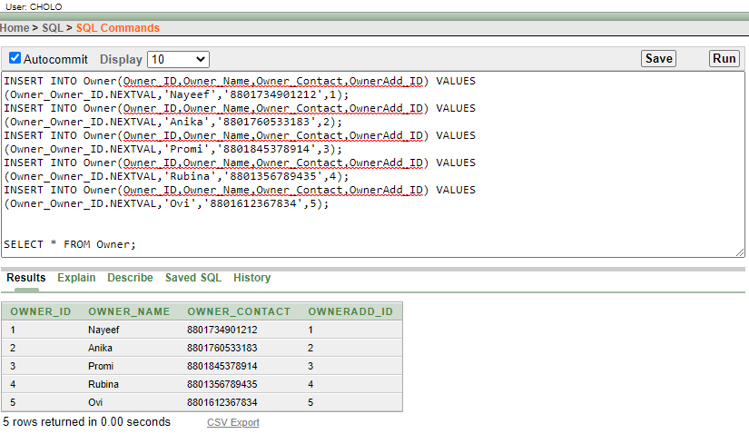

1. Driver_Address

INSERT INTO Driver_Address(DriverAdd_ID, Driver_HouseNo, Driver_StreetNo, Driver_City) VALUES (Driver_DriverAdd_ID.NEXTVAL,'H#33','Mirpur 1','Dhaka');

INSERT INTO Driver_Address(DriverAdd_ID, Driver_HouseNo, Driver_StreetNo, Driver_City) VALUES (Driver_DriverAdd_ID.NEXTVAL,'H#9','Mirpur 11','Dhaka');

INSERT INTO Driver_Address(DriverAdd_ID, Driver_HouseNo, Driver_StreetNo, Driver_City) VALUES (Driver_DriverAdd_ID.NEXTVAL,'H#26','Khilgaon','Dhaka');

INSERT INTO Driver_Address(DriverAdd_ID, Driver_HouseNo, Driver_StreetNo, Driver_City) VALUES (Driver_DriverAdd_ID.NEXTVAL,'H#26','Khilgaon','Dhaka');

INSERT INTO Driver_Address(DriverAdd_ID, Driver_HouseNo, Driver_StreetNo, Driver_City) VALUES (Driver_DriverAdd_ID.NEXTVAL,'H#47','Badda 13','Dhaka');

INSERT INTO Driver_Address(DriverAdd_ID, Driver_HouseNo, Driver_StreetNo, Driver_City) VALUES (Driver_DriverAdd_ID.NEXTVAL,'H#2','Uttara 11','Dhaka');

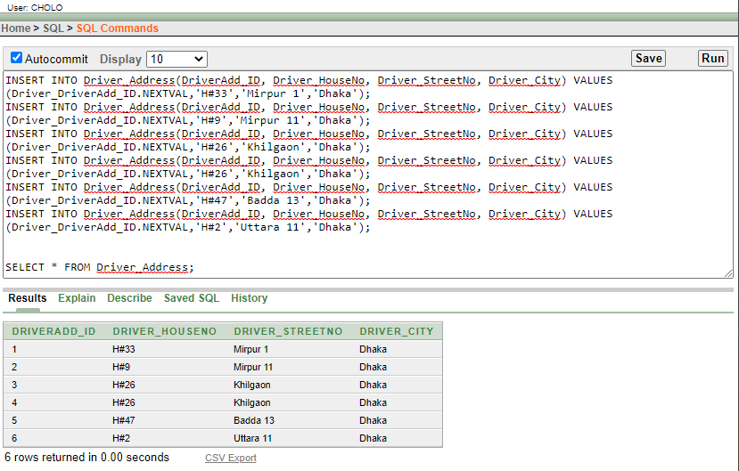

1. Driver

INSERT INTO Driver(Driver_ID, Driver_LicenseNo, Driver_Name, Driver_Contact, DriverAdd_ID) VALUES (Driver_Driver_ID.NEXTVAL, 'N167T895','Abdur Rahim','8801690685435',1);

INSERT INTO Driver(Driver_ID, Driver_LicenseNo, Driver_Name, Driver_Contact, DriverAdd_ID) VALUES (Driver_Driver_ID.NEXTVAL, 'G952K007','Liton Mia','8801883460013',2);

INSERT INTO Driver(Driver_ID, Driver_LicenseNo, Driver_Name, Driver_Contact, DriverAdd_ID) VALUES (Driver_Driver_ID.NEXTVAL, 'L032P883','Abdullah','8801657893028',3);

INSERT INTO Driver(Driver_ID, Driver_LicenseNo, Driver_Name, Driver_Contact, DriverAdd_ID) VALUES (Driver_Driver_ID.NEXTVAL, 'K472T335','Jamal Roshid','8801555389460',4);

INSERT INTO Driver(Driver_ID, Driver_LicenseNo, Driver_Name, Driver_Contact, DriverAdd_ID) VALUES (Driver_Driver_ID.NEXTVAL, 'A364N893','Abdul Kader','8801485730489',5);

INSERT INTO Driver(Driver_ID, Driver_LicenseNo, Driver_Name, Driver_Contact, DriverAdd_ID) VALUES (Driver_Driver_ID.NEXTVAL, 'S887H743','Arif Rahman','8801665209846',6);

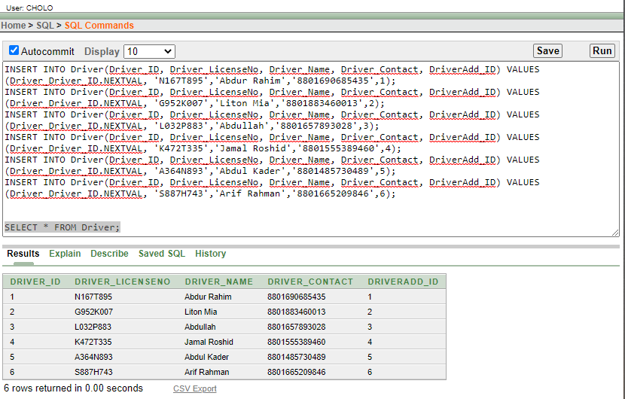

1. Customer_Address

INSERT INTO Customer_Address VALUES(1, 'H#14','Uttara 11','Dhaka');

INSERT INTO Customer_Address VALUES(2, 'H#29','Khilgaon 2','Dhaka');

INSERT INTO Customer_Address VALUES(3, 'H#7','Banani 11','Dhaka');

INSERT INTO Customer_Address VALUES(4, 'H#13','Badda 5','Dhaka');

INSERT INTO Customer_Address VALUES(5, 'H#1','Rampura','Dhaka');

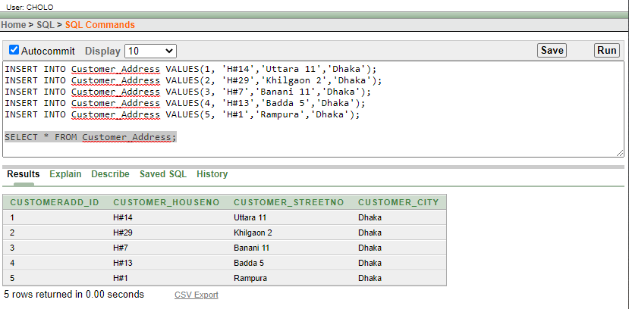

1. Customer

INSERT INTO Customer VALUES(8801938476520, 'Nowfal',1);

INSERT INTO Customer VALUES(8801739283645, 'Ibtesum',2);

INSERT INTO Customer VALUES(8801628396678, 'Sadia',3);

INSERT INTO Customer VALUES(8801557344689, 'Reya',4);

INSERT INTO Customer VALUES(8801462236798, 'Washim',5);

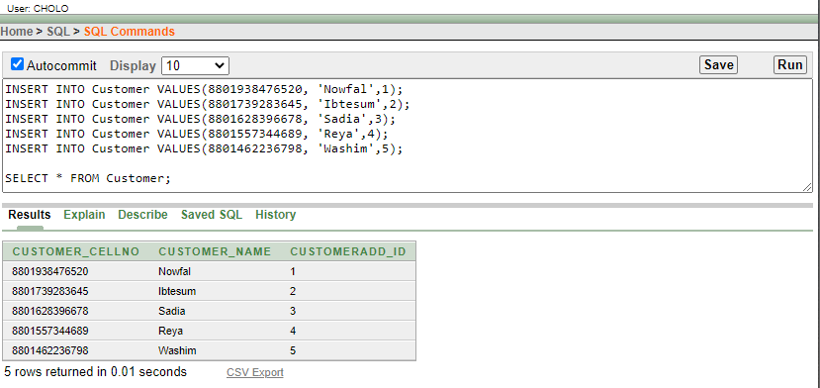

1. Car

INSERT INTO Car(Car_ID, Car_Brand1, Car_Brand2, Car_Brand3, Car_Type1, Car_Type2, Car_Type3,Customer_CellNo, Owner_ID, Driver_ID) VALUES (Car_Car_ID.NEXTVAL,'Axio','Premio', 'Corolla', 'Premium', 'Luxurious', 'Regular', 8801938476520,1,1);

INSERT INTO Car(Car_ID, Car_Brand1, Car_Brand2, Car_Brand3, Car_Type1, Car_Type2, Car_Type3,Customer_CellNo, Owner_ID, Driver_ID) VALUES (Car_Car_ID.NEXTVAL, 'BMW', 'Premio', 'XE Saloon', 'Luxurious', 'Premium', 'Regular', 8801739283645,2,2);

INSERT INTO Car(Car_ID, Car_Brand1, Car_Brand2, Car_Brand3, Car_Type1, Car_Type2, Car_Type3,Customer_CellNo, Owner_ID, Driver_ID) VALUES (Car_Car_ID.NEXTVAL, 'Mercedes', 'Allion', 'G-Corolla', 'Luxurious', 'Premium', 'Regular', 8801628396678,3,3);

INSERT INTO Car(Car_ID, Car_Brand1, Car_Brand2, Car_Brand3, Car_Type1, Car_Type2, Car_Type3,Customer_CellNo, Owner_ID, Driver_ID) VALUES (Car_Car_ID.NEXTVAL, 'Mercedes', 'Nissan', 'X-Corolla', 'Luxurious', 'Premium', 'Regular', 8801557344689,4,4);

INSERT INTO Car(Car_ID, Car_Brand1, Car_Brand2, Car_Brand3, Car_Type1, Car_Type2, Car_Type3,Customer_CellNo, Owner_ID, Driver_ID) VALUES (Car_Car_ID.NEXTVAL, 'Fielder', 'Civic', 'Probox', 'Premium', 'Luxurious', 'Regular', 8801462236798,5,5);

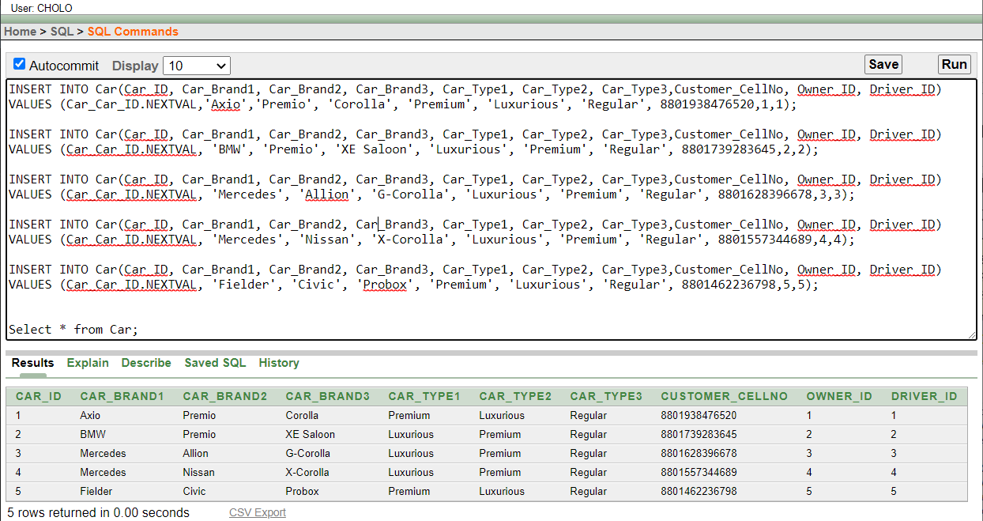

1. Rent

INSERT INTO Rent VALUES(1, 8801938476520, '01:30 PM');

INSERT INTO Rent VALUES(2, 8801739283645, '12:30 PM');

INSERT INTO Rent VALUES(3, 8801628396678, '10:10 AM');

INSERT INTO Rent VALUES(4, 8801557344689, '04:15 PM');

INSERT INTO Rent VALUES(5, 8801462236798, '12:30 PM');

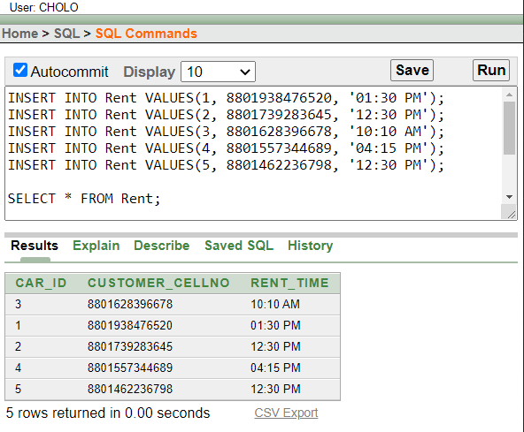

1. Reserve

INSERT INTO Reserve VALUES(1, 8801938476520, to_date('12-02-2021','dd-mm-yyyy'), 101, '01:30 PM');

INSERT INTO Reserve VALUES(2, 8801739283645, to_date('10-01-2021','dd-mm-yyyy'), 102, '10:45 PM');

INSERT INTO Reserve VALUES(3, 8801628396678, to_date('13-02-2021','dd-mm-yyyy'), 103, '04:55 AM');

INSERT INTO Reserve VALUES(4, 8801557344689, to_date('17-03-2021','dd-mm-yyyy'), 104, '08:35 PM');

INSERT INTO Reserve VALUES(5, 8801462236798, to_date('28-03-2021','dd-mm-yyyy'), 105, '11:00 PM');

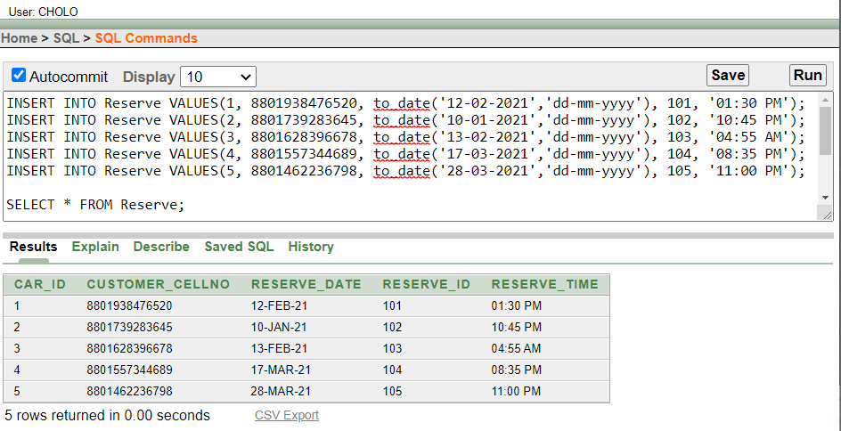

# **Query Writing**

Subquery:

1. Display those Car ID and Reserve ID where Reserve ID is greater than 102

**Ans**: SELECT Reserve_ID, Car_ID FROM Reserve

WHERE Car_ID>(SELECT Car_ID FROM Reserve WHERE Reserve_ID=102);

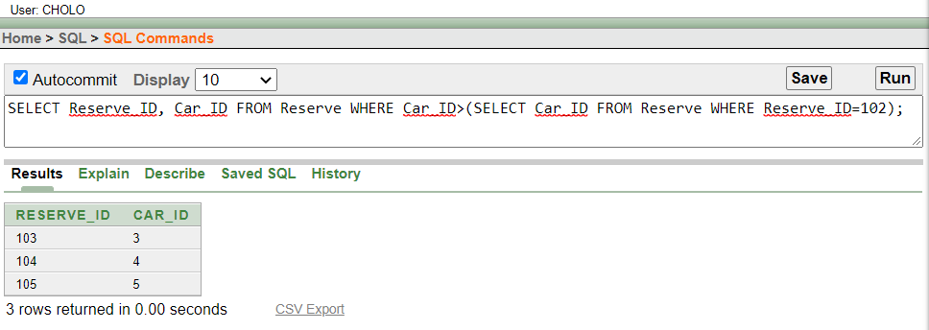

1. Display the Car Brand1 and the Driver ID where Car Type1 is premium

**Ans**: SELECT Car_Brand1, Driver_ID FROM Car WHERE Car_Brand1 IN (SELECT

Car_Brand1 FROM Car WHERE Car_Type1=‘Premium’);

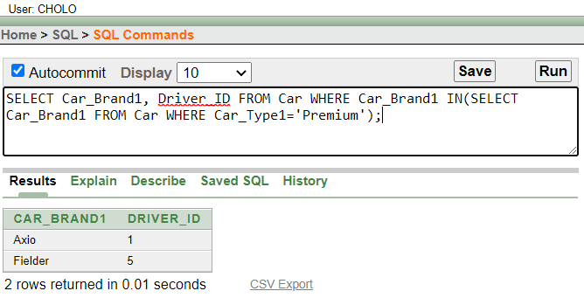

Joining:

1. Write a query to display Driver name, Car Type1 and Car Brand1 for all drivers.

**Ans**: SELECT d.Driver_Name, c.Car_Type1, c.Car_Brand1

FROM Driver d, Car c

WHERE d.Driver_ID=c.Driver_ID;

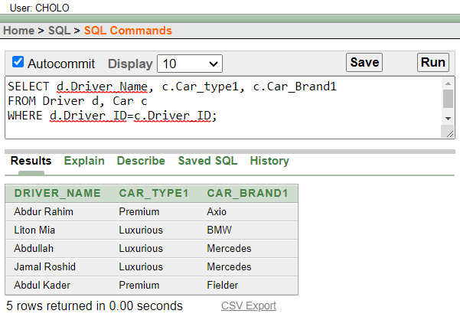

1. Display all the Driver name, Driver LicenseNo and their car ID. Make sure that the drivers that is not assigned with a car are also displayed.

**Ans**: SELECT d.Driver_Name, d.Driver_LicenseNo, c.Car_ID

From Driver d, Car c

WHERE d,Driver_ID=c.Driver_ID(+);

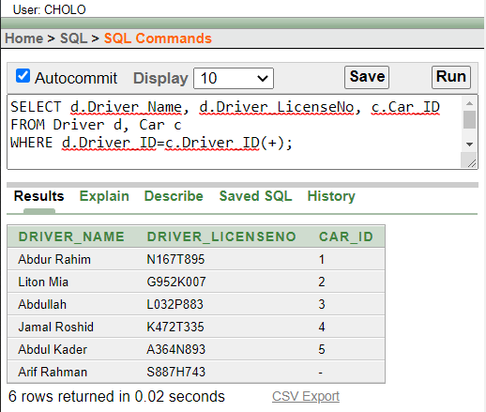

View:

Grant Create View TO CHOLO; [System]

1. Create a view called CarView based on the Car_ID, Car_Brand1, Car_Type1,

Customer_CellNo from Car table. Display the contents of carView.

**Ans:** CREATE VIEW CarView

AS SELECT Car_ID, Car_Brand1, Car_Type1, Customer_CellNo

FROM Car;

SELECT * FROM CarView;

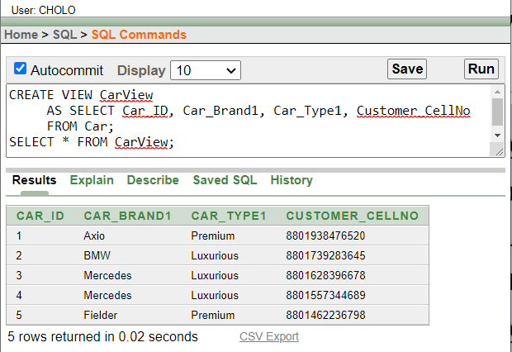

1. Write a query to display Car ID, Car Brand1, Car Type1 and Customer CellNo where Car Type1 is Luxurious from Car Table.

**Ans:** SELECT Car_ID, Car_Brand1, Car_Type1, Customer_CellNo

FROM CarView

WHERE Car_Type1='Luxurious';

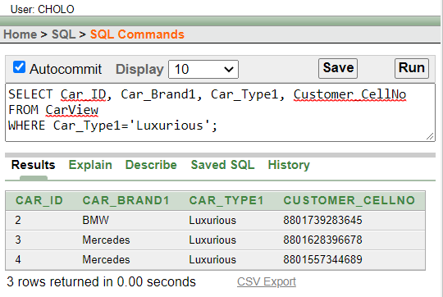

# **Relational Algebra**

1. Find the Car ID whose customer CellNo is “8801557344689” from the Car Table

∏Car_ID (σ Customer_CellNo = “8801557344689” (Car))

1. Find the driver name and contact whose License NO is “G952K007” from the Driver Table

∏Driver_Name, Driver_Contact (σ Driver_LicenseNo = “G952K007” (Driver))

1. Find the Customer CellNo who reserved on 12 FEB 2021 from Reserve table

∏Customer_CellNo (σ Reserve_Date = “12-02-2021” (Reserve))

1. Find the Rent Time whose Car ID is 4 from Rent table

∏Rent_Time (σ Car_ID = 4 (Rent))

1. Find the Owner Name and Owner ID whose Contact No is 8801612367834 from Owner Table

∏Owner_Name, Owner_ID (σ Owner_Contact = “8801612367834” (Owner))

# **Conclusion**

After the efforts by all our group members we created our database management project “Car Ride Hailing Management System”. Initially we faced some problems but then we were able to overcome that. Such as if we could add the fare of the renting of a car it would be better to operate. If we could Add the salary for the drivers it would be easier to sort the drivers according salaries and also experience.

Hopefully in future we will work to use our database system to work for the whole country not only in Dhaka city. We will be able to create real database system for organizations.